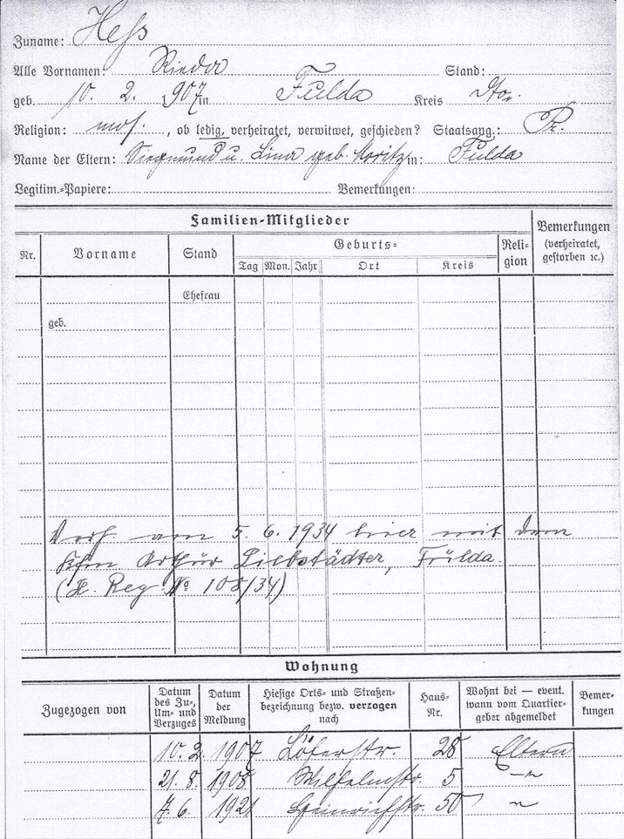

Family name: Hess

all first names: Rieda profession: none

born: February 10th 1907 in: Fulda district: dito

religion: jewish, single national: Prussia

names of parents: Siegmund and Lina born Moritz in: Fulda

family-members

married on June 5th 1934 here with the merchant Arthur Liebstädter, Fulda.  
(marriage register Nr. 108/34)

appartment

February 10th 1907 Löherstrasse 28 parents

August 21st 1908 Wilhelmstrasse 5 ‘’

June 7th 1921 Heinrichstrasse 50 ‘’