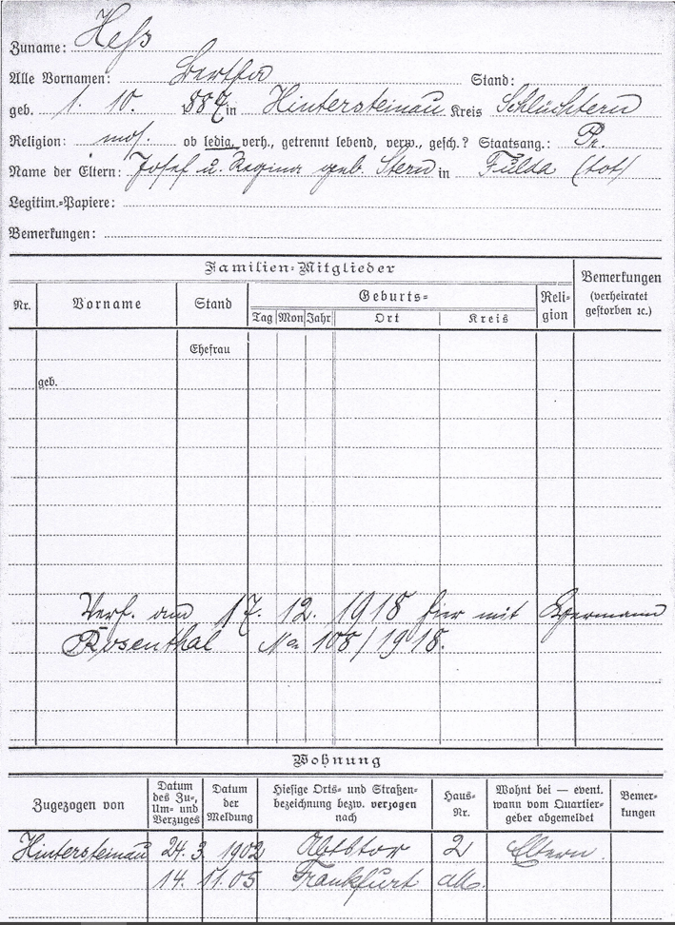

Family name: Hess

All first names: Bertha

Born: October 1st 1887 at Hintersteinau district Schluechtern

Religion: jewish single national: Prussia

Names of parents: Josef and Regina vorn Stern at: Fulda (deceased)

Family-members

Written on December 17th 1918 here with Hermann Rosenthal Nr. 108/1918

Appartment

dd mm yyyy

Hintersteinau 24. 03. 1902 Abtstor 2 parents

14. 11. 1905 Frankfort on Main