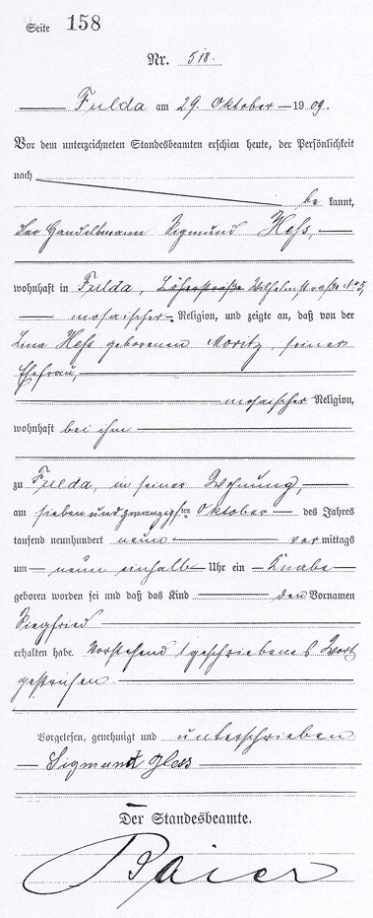

Page 158

Nr. 518

Fulda on the October 29th 1909

In front of the signed registrar appeared today, known by personality, the merchant Sigmund Hess, living in Fulda, Wilhelmstrasse Nr. 5, of jewish religion, and indicated that from Lina Hess born Moritz, his wife, of jewish religion, living with him at Fulda, in his flat, was born on the October 27th of the year nineteen hundered and nine in the morning at nine and a half o’clock a boy and that the child got the first name Siegfried. One written word has been deleted above.

Read, approved and signed : Sigmund Hess

The registrar: Baier.»