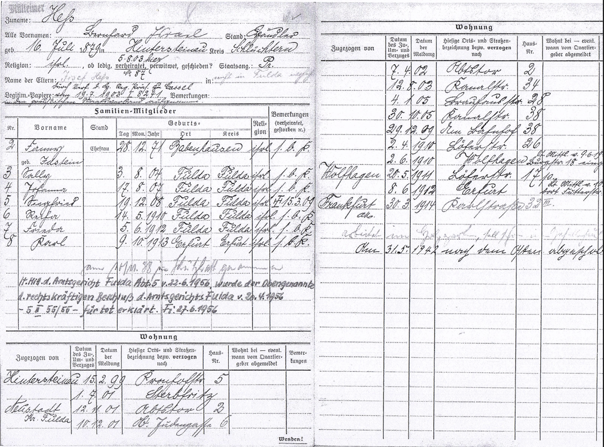

Family name: Hess  
All first names: Leonhard Israel Profession: Dealer  
born: 16. July 1879 at: Hintersteinau district: Schluchtern  
religion: jewish, if unmarried married (5. August 1903 here) widowed divorced? national of: Pr[ussia]  
Names of parents: Josef Hess in: not in Fulda … [? not readable]  
Identification papers: national to the prussian state assosation by decree of the district government president of Cassel from July 19th 1903 I 8241.

Family members

Nr. first name civil status day month year of birth place district religion remarks

2 Fanny Wife 28 12 1871 Babenhausen jewish s.b.K.  
 born Idstein  
3 Sally 3 8 1904 Fulda Fulda jewish s.b.K.  
4 Johanna 17 8 1907 Fulda Fulda jewish s.b.K.  
5 Siegfried 19 12 1908 Fulda Fulda jewish † 15.03.1909  
6 Recha 14 5 1910 Fulda Fulda jewish s.b.K.  
7 Frieda 5 6 1912 Fulda Fulda jewish s.b.K.  
8 Karl 9 10 1913 Erfurt Erfurt jewish s.b.K.  
  
 taken into protective custody on november 10th 1938  
according tot he announcement of the District Court of Fulda, department 5, from june 22nd 1956 the above was declared dead by legally binding decision of the District Court on april 20th 1956 – 5 II 1955/56. Fi june 27th 1956.

Appartment

moved from date of the arrival, date of report local place and street name house nr. lives with  
 move or moving away respectively moved to possibly when  
 logged out by  
 accomodation  
 provider

Hintersteinau 15. febr. 1899 Kronhofstrasse 5  
 1. july 1901 Sterbfritz  
Neustadt, 12. novemb. 1901 Abtstor 2  
 distr. Fulda  
 10. decemb. 1901 Ob. Judengasse 6

(next page)  
 7. april 1902 Abtstor 2  
 12. august 1903 Kanalstrasse 34  
 4. january 1905 Brauhausstrasse 28  
 30. october 1905 Kanalstrasse 38  
 29. december 1909 Am Bahnhof 38  
 2. april 1910 Löherstrasse 26  
 2. june 1910 Wolfhagen according to   
 the   
 announcement   
 from june 9th   
 19 registered   
 at Burgstr. 18  
Wolfhagen 20. may 1911 Löherstrasse 17  
 8. june 1912 Erfurt according to   
 the   
 announcement  
 from [june?]  
 10th there  
 Futterstrasse  
Frankfurt a/Main 30. march 1914 Karlstrasse 32, IIIrd floor

is working at Holzgarten, should already at the Journeyman’s house

At may 31st 1942 deported tot he East.