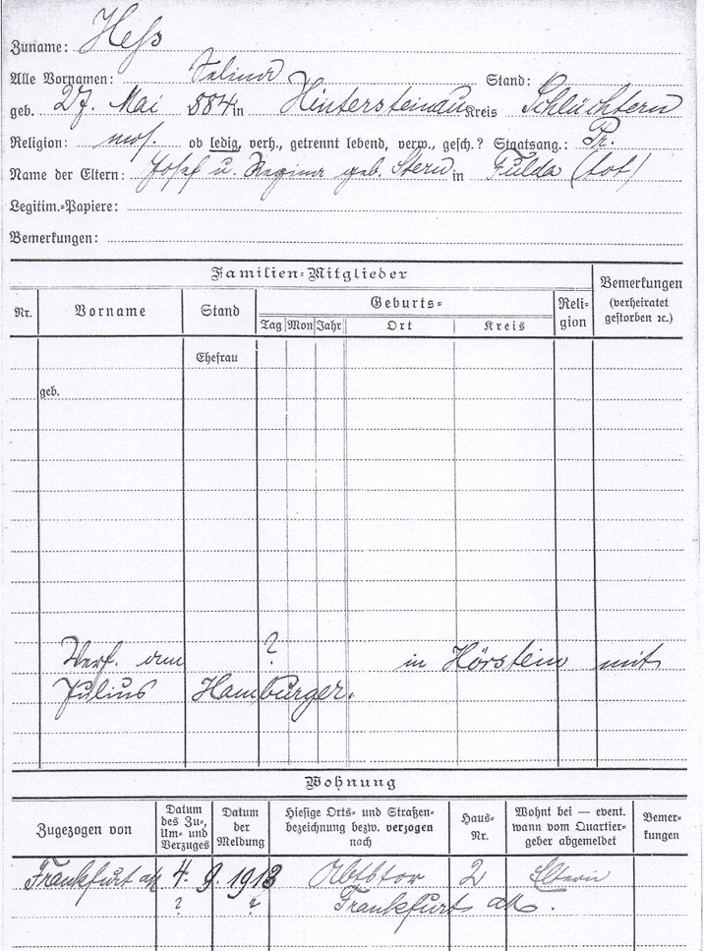

Family name: Hess

All first names: Selina

Born: May 27th 1884 in: Hintersteinau district: Schluechtern

Religion: jewish married national: Prussia

Names of parents: Josef and Regina born Stern in Fulda (deceased)

Family-members

Written on ? at Hoerstein with Julius Hamburger.

Appartment

dd mm yyyy

Frankfurt on Main 04.09.1913 Abtstor 2 parents

? ? Frankfurt on Main